A Different Kind of Winetasting party
Coming at the October 7th BSPS Zoom dinner meeting

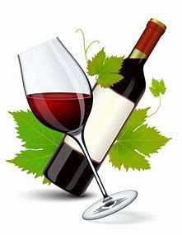

Wine is for sharing, for drinking with friends or family over a meal. Enjoying a good wine often requires companionship. Unfortunately, in our current COVID-19 world sharing a wine is a Tricky Dance. However, the good news is that YOU will be able to do so. You will have the opportunity to share your favorite wine with BSPS Zoom participants by giving a quick tasty presentation of the wine characteristics in the privacy of your own home. And guess what, there’s no charge except for the bottle of wine that you would buy anyway.

Please plan to join us for fun and giggles. Details to follow, (A Zoom reservation will be required)

